ULTRASONIC TESTING REPORT
Company/Client |  | NCOC N. V. |  | Project |  | ESKENE WEST |  | Location |  | Oil Tr-2
Line No/Tag No: |  | A1-2102-RO-130-1”-A13-WN |  | Material |  | A333 Gr.6 SMLS |  | Día × Nominal Thickness |  | 1’’x4.55mm
Procedure No: |  | QP-11-UTT-Q01 Rev 03  GOST 28702-90 |  | Calibration Block |  | Step wedge |  | Probe  S/N |  | D7908  1214571
 |  |  |  | Calibration block Range |  | 2.50-12.50 mm |  | Angle |  | 0º
Manufacturing Code |  | ASME B31.3 |  | Calibration Temp |  | -1ºC |  | Frequency |  | 7.5 MHz
 |  |  |  | Object Temp |  | -1ºC |  | Size |  | 5.1 mm
Acceptance Standard: |  | Acc. to the client specif. |  | Correction factors |  | n/a |  | Crystal |  | Dual
Surface condition |  | Coated |  | Couplant |  | UT Gel |  | Accuracy |  | ± 0,1 mm
S. No | Equipment/  Material Name |  | Manufacturer |  | Serial No |  | Calibration certificate No |  | Calibration Expiry date
 | DL-38 |  | OLYMPUS |  | 171421601 |  | BK-01-0674 |  | 20-03-2020
 | Step calibration block 2214M |  | OLYMPUS |  | 026519 |  | - |  | -
Job description:

- UT spot check performed on disulphide line A1-2102-RO-130-1”-A13-WN (drawing No KE01-A1-210-PO-P-DI-8115-052).
- Inspection performed on East, West, South, North, Top, Bottom and Extrados from external.
- Echo to echo UT technique was used.
Notes:
N/A – not applicable.

Inspection drawing
A1-2102-RO-130-1”-A13-WN

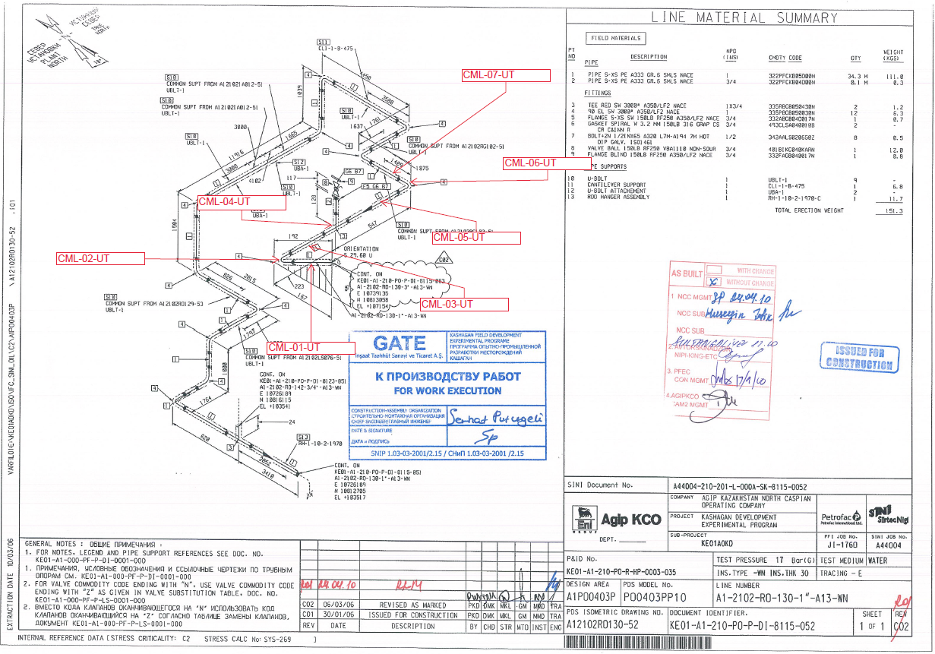

Inspection results
S/NO | Location | Item description | Spot check  Location | DIA(Ø), inch | Nominal thickness, mm | Top  mm | Bottom  mm | East  mm | West  mm | South  mm | North  mm | Extrados mm
1 | CML-01 | Pipe | 1 | 1 | 4.55 | 4.48 | 4.38 | 4.44 | 4.55 | - | - | -
2 | CML-02 | Elbow | 1 | 1 | 4.55 | 5.62 | 5.55 | - | - | - | - | 5.29
3 | CML-03 | Pipe | 1 | 1 | 4.55 | 4.44 | 4.25 | - | - | 4.41 | 4.38 | -
4 | CML-04 | Tee | 1 | 1 | 4.55 | - | - | 5.16 | 5.23 | 5.11 | 5.02 | -
5 | CML-04 | Tee | 2 | 1 | 4.55 | - | 5.60 | - | - | 5.52 | 5.94 | -
6 | CML-05 | Pipe | 1 | 1 | 4.55 | 4.34 | 4.21 | - | - | 4.23 | 4.35 | -
7 | CML-06 | Elbow | 1 | 1 | 4.55 | 6.41 | 7.05 | - | - | - | - | -
8 | CML-07 | Pipe | 1 | 1 | 4.55 | 4.38 | 4.42 | 4.08 | 4.61 | - | - | -

Remarks: UT spot-check on tee according to the drawings below.
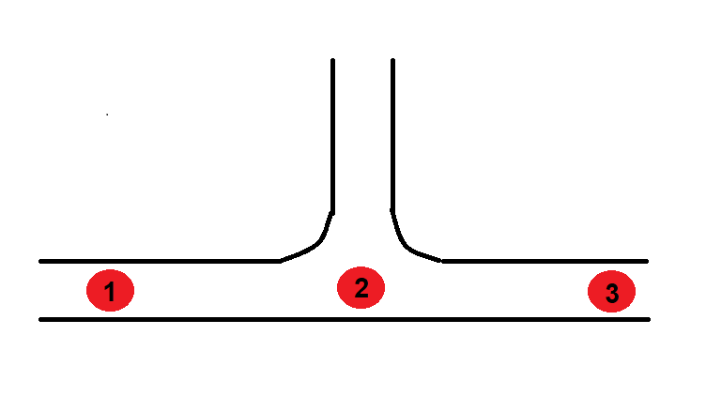
4
1

Examined by  UT L II cert. No 355  expiry date: 16.04.2021 | Name: Dariskaliyev Nurdaulet | Signature: ............................ | Date: 28 Jan 2020
Approved by:  UT L II cert. No 1A 167/17  expiry date 31.01.2022 | Name: Barsukou Raman | Signature: .......................... | Date: 28 Jan 2020
Client Representative: | Name: …………………………… | Signature: ............................ | Date: ………………

